CE373 D17CE137

Practical-1

Aim : Installation of Android in Windows with Simulator and Introduction to
Android Life Cycle & Introduction to UI/XI.

STEP 1: DOWNLOAD AND INSTALL THE JAVA RUNTIME ENVIRONMENT (JRE)

You can find the download file here:
http://www.oracle.com/technetwork/java/javase/downloads/jre-6u25-download-346243.html.

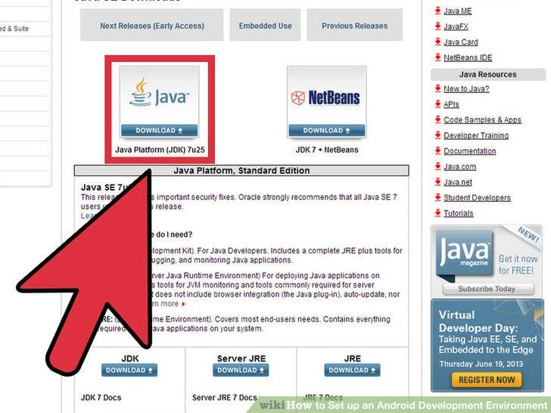

STEP 2: DOWNLOAD AND INSTALL THE JAVA DEVELOPMENT KIT.
On some Windows systems, the launcher script does not find where the JDK is installed. If you encounter this problem, you need to set an environment variable indicating the correct location.
Select Start menu > Computer > System Properties > Advanced System Properties. Then open Advanced tab > Environment Variables and add a new system variable JAVA_HOME that points to your JDK folder, for example C:\Program
Files\Java\jdk1.7.0_21.

1
CE373 D17CE137

STEP 3: DOWNLOAD ANDROID STUDIO

The Android Software Development Kit (referred to in this License Agreement as the "SDK" and specifically including the Android system files, packaged APIs, and Google APIs add-ons) is licensed to you subject to the terms of this License Agreement. This License Agreement forms a legally binding contract between you and Google in relation to your use of the SDK.
You can install android studio by following link:

http://developer.android.com/sdk/index.html#top

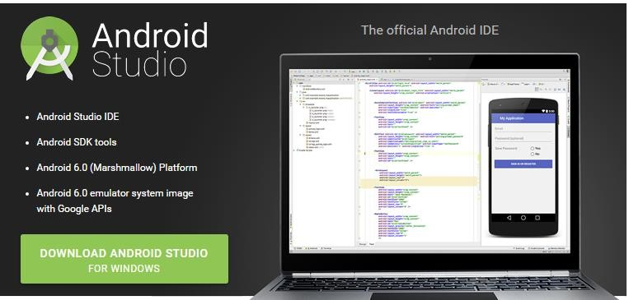

STEP 4: ADDING SDK PACKAGES

The Android SDK does not include everything you need to start developing. The SDK separates tools, platforms, and other components into packages you can download as needed using the Android SDK Manager. So before
you can start, there are a few packages you should add to your Android SDK.

2
CE373 D17CE137

To start adding packages, launch the Android SDK Manager in one of the following ways:

In Android Studio, click SDK Manager in the toolbar.

If you're not using Android Studio:

o Windows: Double-click the SDK Manager.exe file at the root of the Android SDK directory.

o Mac/Linux: Open a terminal and navigate to the tools/ directory in the location where the Android SDK

was installed, then execute android sdk.

When you open the SDK Manager for the first time, several packages are selected by default. Leave these selected, but be sure you have everything you need to get started by following these steps:
Get the latest SDK tools

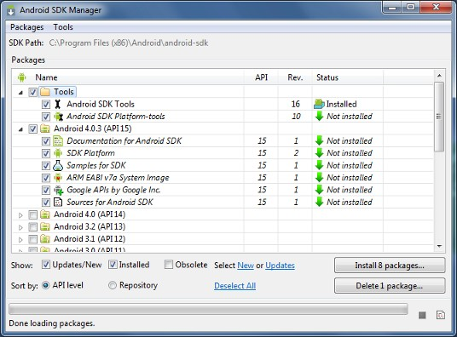

As a minimum when setting up the Android SDK, you should download the latest tools and Android platform:

1. Open the Tools directory and select:

o Android SDK Tools

o Android SDK Platform-tools

o Android SDK Build-tools (highest version)

2. Open the first Android X.X folder (the latest version) and select:

o SDK Platform

3
CE373 D17CE137

o A system image for the emulator, such as

ARM EABI v7a System Image

Get the support library for additional APIs

The support library is required for:

Android Wear

Android TV

Google Cast

It also provides these popular APIs:

Navigation drawer

Swipe views

Backward-compatible action bar

The Android Support Library provides an extended set of APIs that are compatible with most versions of

Android.

Open the Extras directory and select:

Android Support Repository

Android Support Library

Get Google Play services for even more APIs

The Google Play services APIs provide a variety of features and services for your Android apps, such as:

User authentication

Google Maps

Google Cast

Games achievements and leaderboards

And much more

To develop with Google APIs, you need the Google Play services package:

Open the Extras directory and select:

4
CE373 D17CE137

Google Repository

Google Play services

Note: Google Play services APIs are not available on all Android-powered devices, but are available on all devices with Google Play Store. To use these APIs in the Android emulator, you must also install the the Google APIs system image from the latest Android X.X directory in the SDK Manager.

INSTALL THE PACKAGES

Once you've selected all the desired packages, continue to install:

1. Click Install X packages.

2. In the next window, double-click each package name on the left to accept the license agreement for each.

3. Click Install.

The download progress is shown at the bottom of the SDK Manager window. Do not exit the SDK Manager or it will cancel the download.

STEP 5: ANDROID PROJECT VIEW

By default, Android Studio displays your project files in the Android project view. This view shows a flattened version of your project's structure that provides quick access to the key source files of Android projects and helps you work with the Gradle-based build system. The Android project view:

Shows the most important source directories at the top level of the module hierarchy.

Groups the build files for all modules in a common folder.

Groups all the manifest files for each module in a common folder.

Shows resource files from all Gradle source sets.

Groups resource files for different locales, orientations, and screen types in a single group per resource type.

5
CE373 D17CE137

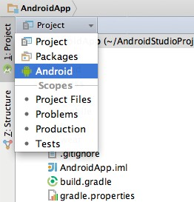

Figure: Show The Android Project View.

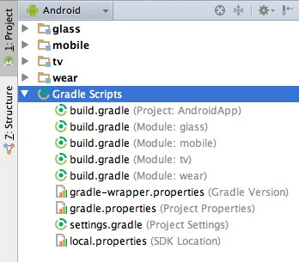

Figure: Show Project Build Files.

The Android project view shows all the build files at the top level of the project hierarchy under Gradle Scripts. Each project module appears as a folder at the top level of the project hierarchy and contains these four elements at the top level:

6
CE373 D17CE137

java/ - Source files for the module.

manifests/ - Manifest files for the module.

res/ - Resource files for the module.

Gradle Scripts/ - Gradle build and property files.

For example, Android project view groups all the instances of the ic_launcher.png resource for different screen densities under the same element.

Note: The project structure on disk differs from this flattened representation. To switch to back to the segregated project view, select Project from the Project drop-down.

Other Android Studio views

When you use the Project view in Android Studio, you should notice that the project structure appears different than you may be used to in Eclipse. Each instance of Android Studio contains a project with one or more application modules. Each application module folder contains the complete source sets for that module, including src/main/ andsrc/androidTest/ directories, resources, build file and the Android manifest. For the most part, you will need to modify the files under each module's src/main/ directory for source code updates, the gradle.build file for build specification and the files under src/androidTest/ directory for test case creation.
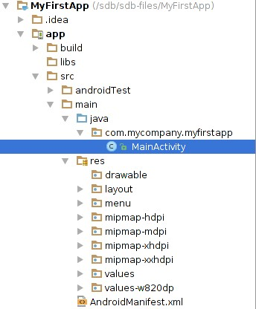

Figure: View Android Studio Project structure.

7
CE373 D17CE137

Android Virtual Device (AVD) Manager

AVD Manager has updated screens with links to help you select the most popular device configurations, screen sizes and resolutions for your app previews.
Click the Android Virtual Device Manager  in the toolbar to open it and create new virtual devices for running your app in the emulator.

The AVD Manager comes with emulators for Nexus 6 and Nexus 9 devices and also supports creating custom Android device skins based on specific emulator properties and assigning those skins to hardware profiles. Android Studio installs the Intel® x86 Hardware Accelerated Execution Manager (HAXM) emulator accelerator and creates a default emulator for quick app prototyping.

For more information, see Managing AVDs.

Android Activity Lifecycle

Android Activity Lifecycle is controlled by 7 methods of android.app.Activity class. The android
Activity is the subclass of ContextThemeWrapper class.

An activity is the single screen in android. It is like window or frame of Java.

By the help of activity, you can place all your UI components or widgets in a single screen. The 7 lifecycle method of Activity describes how activity will behave at different states.
Android Activity Lifecycle methods

Let's see the 7 lifecycle methods of android activity.

Method Description

onCreate called when activity is first created.

onStart called when activity is becoming visible to the user.

onResume called when activity will start interacting with the user.

8
CE373 D17CE137

onPause called when activity is not visible to the user.

onStop called when activity is no longer visible to the user.

onRestart called after your activity is stopped, prior to start.

onDestroy called before the activity is destroyed.

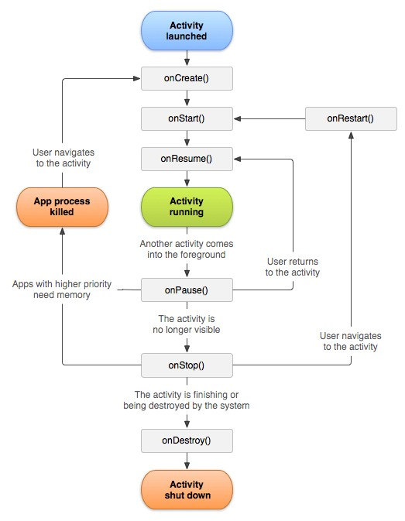

9
CE373 D17CE137

Practical-2

Aim : I. Create “Hello World” application. That will display “Hello World” in the middle of the screen in the red color with white background. II.To understand Activity, Intent Create sample application with login module.(Check username and password) On successful login, go to next screen. And on failing login, alert user using Toast. Also pass username to next screen.

Create “Hello World” application. That will display “Hello World” in the
middle of the screen in the red color with white background

Activity_main.xml:

<?xml version="1.0" encoding="utf-8"?>
<LinearLayout xmlns:android="http://schemas.android.com/apk/res/android" xmlns:tools="http://schemas.android.com/tools"
android:layout_width="match_parent" android:layout_height="match_parent"
android:orientation="vertical" android:paddingBottom="@dimen/activity_vertical_margin" android:paddingLeft="@dimen/activity_horizontal_margin" android:paddingRight="@dimen/activity_horizontal_margin" android:paddingTop="@dimen/activity_vertical_margin" tools:context="com.example.user.myapplication.MainActivity">
<TextView android:id="@+id/tvHello" android:layout_width="match_parent" android:layout_height="wrap_content" android:layout_gravity="center_vertical" android:layout_margin="40dp" android:padding="50dp" android:gravity="center" android:text="Hello world!" android:textColor="@color/colorRed" android:textSize="52sp" android:textStyle="bold|italic" />
</LinearLayout>

OUTPUT :

10
CE373 D17CE137

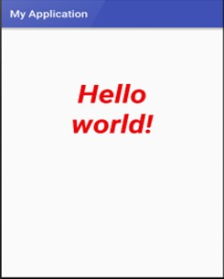

To understand Activity, Intent Create sample application with login module.(Check username and password) On successful login, go to next screen. And on failing login, alert user using Toast. Also pass username to next screen.

activity_main.xml

<RelativeLayout xmlns:android="http://schemas.android.com/apk/res/android" xmlns:tools="http://schemas.android.com/tools" android:layout_width="match_parent" android:layout_height="match_parent" android:paddingBottom="@dimen/activity_vertical_margin" android:paddingLeft="@dimen/activity_horizontal_margin" android:paddingRight="@dimen/activity_horizontal_margin" android:paddingTop="@dimen/activity_vertical_margin">

<TextView

11
CE373 D17CE137

android:id="@+id/textView1" android:layout_width="wrap_content" android:layout_height="wrap_content" android:layout_alignParentTop="true" android:layout_centerHorizontal="true" android:layout_marginTop="36dp" android:text="Login"
android:textAppearance="?android:attr/textAppearanceMedium" />

<EditText android:id="@+id/editText1" android:layout_width="300dp" android:layout_height="wrap_content" android:layout_below="@+id/textView1" android:layout_centerHorizontal="true" android:layout_marginTop="34dp" android:hint="Username">

<requestFocus />

</EditText>

<EditText android:id="@+id/editText2" android:layout_width="300dp"
android:layout_height="wrap_content"

12
CE373 D17CE137

android:layout_centerHorizontal="true" android:layout_centerVertical="true" android:hint="Password" android:inputType="textPassword" />

<Button android:id="@+id/button1" android:layout_width="wrap_content" android:layout_height="wrap_content" android:layout_below="@+id/editText2" android:layout_centerHorizontal="true" android:layout_marginTop="28dp" android:text="Login" />

<TextView android:id="@+id/textView2" android:layout_width="wrap_content" android:layout_height="wrap_content" android:layout_below="@+id/button1" android:layout_centerHorizontal="true" android:layout_marginTop="32dp" android:textAppearance="?android:attr/textAppearanceMedium" />

</RelativeLayout>

13
CE373 D17CE137

mainactivity.java

package com.example.hp.myapplication;

import android.app.Activity; import android.content.Intent; import android.os.Bundle; import android.view.Menu; import android.view.MenuItem; import android.view.View; import android.widget.Button; import android.widget.EditText; import android.widget.Toast;

public class MainActivity extends Activity {

Button bt1; EditText et1,et2;

@Override

protected void onCreate(Bundle savedInstanceState) {

super.onCreate(savedInstanceState);

setContentView(R.layout.activity_main);

14
CE373 D17CE137

bt1 = (Button) findViewById(R.id.button1);

et1 = (EditText) findViewById(R.id.editText1);

et2 = (EditText) findViewById(R.id.editText2);

bt1.setOnClickListener(new View.OnClickListener() {

@Override

public void onClick(View arg0) {

// TODO Auto-generated method stub

if(et1.getText().toString().equals("adarsh") &&
et2.getText().toString().equals("adarsh") )

{

Intent i = new Intent(getApplicationContext(),MainActivity2.class);

startActivity(i);

}

else

{

Toast.makeText(getApplicationContext(), "Invalid Userid/Password", Toast.LENGTH_LONG).show();

}

}

15
CE373 D17CE137

});

}

@Override

public boolean onCreateOptionsMenu(Menu menu) {

getMenuInflater().inflate(R.menu.main, menu);

return true;

}

@Override

public boolean onOptionsItemSelected(MenuItem item) {

int id = item.getItemId();

if (id == R.id.action_settings) {

return true;

}

return super.onOptionsItemSelected(item);

}

}

activity_main2.xml

16
CE373 D17CE137

<RelativeLayout xmlns:android="http://schemas.android.com/apk/res/android" xmlns:tools="http://schemas.android.com/tools" android:layout_width="match_parent" android:layout_height="match_parent" android:paddingBottom="@dimen/activity_vertical_margin" android:paddingLeft="@dimen/activity_horizontal_margin" android:paddingRight="@dimen/activity_horizontal_margin" android:paddingTop="@dimen/activity_vertical_margin">

<TextView android:id="@+id/textView2" android:layout_width="wrap_content" android:layout_height="wrap_content" android:layout_centerHorizontal="true" android:layout_centerVertical="true" android:text="Welcome to Activity 2"
android:textAppearance="?android:attr/textAppearanceMedium" />

<TextView android:id="@+id/textView1" android:layout_width="wrap_content" android:layout_height="wrap_content" android:layout_below="@+id/textView2"
android:layout_centerHorizontal="true"

17
CE373 D17CE137

android:layout_marginTop="64dp" android:textAppearance="?android:attr/textAppearanceMedium" />

</RelativeLayout>

main2activity.java

package com.example.hp.myapplication;

import android.app.Activity; import android.os.Bundle; import android.view.Menu; import android.view.MenuItem;

public class MainActivity2 extends Activity {

@Override

protected void onCreate(Bundle savedInstanceState) { super.onCreate(savedInstanceState); setContentView(R.layout.activity_main_activity2);
}

@Override

18
CE373 D17CE137

public boolean onCreateOptionsMenu(Menu menu) {

getMenuInflater().inflate(R.menu.main_activity2, menu);

return true;

}

@Override

public boolean onOptionsItemSelected(MenuItem item) {

int id = item.getItemId();

if (id == R.id.action_settings) {

return true;

}

return super.onOptionsItemSelected(item);

}

}

Output:

19
CE373 D17CE137

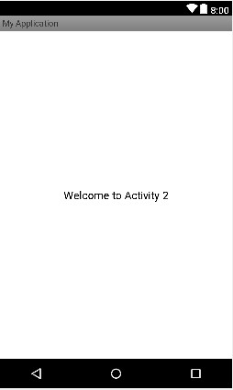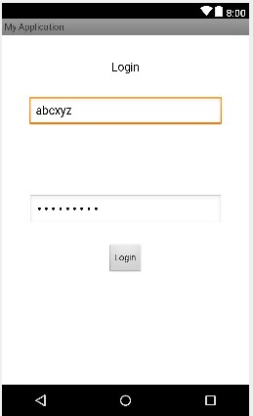

20
CE373 D17CE137

Practical-3

Aim :Create login application where you will have to validate EmailID (UserName). Till the username andpassword is not validated , login button should remain disabled. Create and Login application as above . On successful login , open browser with any URL

activity_main.xml

<RelativeLayout xmlns:android="http://schemas.android.com/apk/res/android" android:layout_width="fill_parent"
android:layout_height="fill_parent" >

<TextView android:id="@+id/textView2" android:layout_width="wrap_content" android:layout_height="wrap_content" android:layout_below="@+id/editText1" android:layout_marginTop="52dp" android:layout_toLeftOf="@+id/editText2" android:text="Password" android:textAppearance="?android:attr/textAppearanceLarge" />

<EditText android:id="@+id/editText2" android:layout_width="wrap_content"
android:layout_height="wrap_content"

21
CE373 D17CE137

android:layout_alignLeft="@+id/editText1" android:layout_alignTop="@+id/textView2" android:ems="10" android:inputType="textPassword" />

<Button android:id="@+id/button1" android:layout_width="wrap_content" android:layout_height="wrap_content" android:layout_below="@+id/editText2" android:layout_centerHorizontal="true"

mainactivity.java

package com.example.hp.myapplication;

import android.app.Activity; import android.content.Intent; import android.net.Uri;
import android.os.Bundle; import android.view.Menu; import android.view.MenuItem; import android.view.View; import android.widget.Button;
import android.widget.EditText;

22
CE373 D17CE137

public class MainActivity extends Activity {

EditText et1,et2; Button b1;

@Override

protected void onCreate(Bundle savedInstanceState) { super.onCreate(savedInstanceState); setContentView(R.layout.activity_main);

et1 = (EditText) findViewById(R.id.editText1); et2 = (EditText) findViewById(R.id.editText2); b1 = (Button) findViewById(R.id.button1);

b1.setOnClickListener(new View.OnClickListener() {

@Override

public void onClick(View v) {

String s1 = et1.getText().toString(); String s2 = et2.getText().toString();

if(s1.equals("admin") && s2.equals("admin"))

23
CE373 D17CE137

{

Intent i= new Intent("android.intent.action.VIEW");

i.setData(Uri.parse("http://www.google.com"));

startActivity(i);

}

}

});

}

@Override

public boolean onCreateOptionsMenu(Menu menu) {

getMenuInflater().inflate(R.menu.main, menu);

return true;

}

@Override

public boolean onOptionsItemSelected(MenuItem item) {

return super.onOptionsItemSelected(item);

}

}

24
CE373 D17CE137

Output:

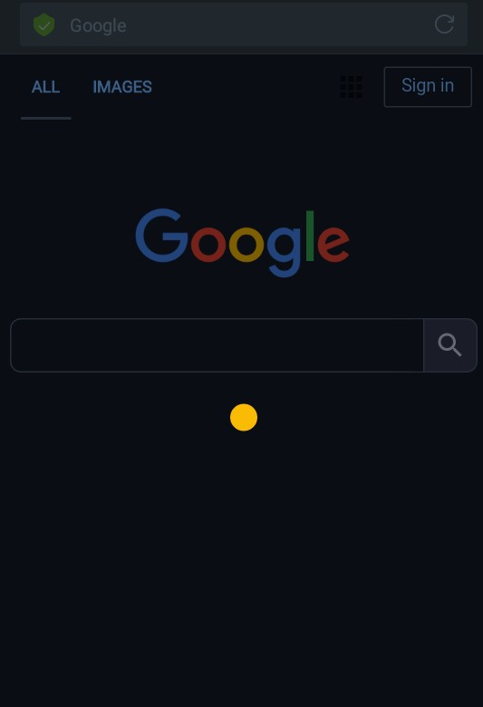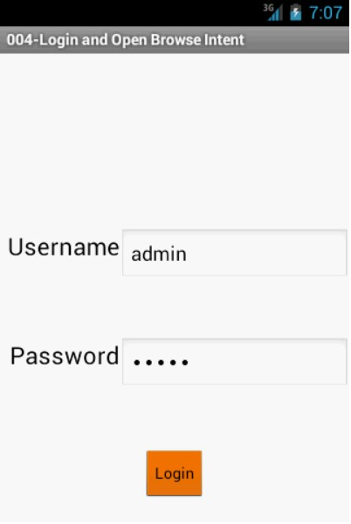

25
CE373 D17CE137

Practical-4

Aim : Create an application that will pass some number to the next screen , and on the next screen that number of items should be display in the list. Understand resource folders : Create spinner with strings taken from resource folder(res >> value folder). On changing spinner value, change image. Understand Menu option. Create an application that will change color of the screen, based on selected options from the menu

Create an application that will pass some number to the next screen , and on the next screen that number of items should be display in the list.
Activity_main.xml :
<RelativeLayout xmlns:android="http://schemas.android.com/apk/res/android" xmlns:tools="http://schemas.android.com/tools" android:layout_width="match_parent" android:layout_height="match_parent" android:paddingBottom="@dimen/activity_vertical_margin" android:paddingLeft="@dimen/activity_horizontal_margin" android:paddingRight="@dimen/activity_horizontal_margin" android:paddingTop="@dimen/activity_vertical_margin" tools:context="gtu.moc.prog05.MainActivity" >

<TextView android:id="@+id/textView1" android:layout_width="wrap_content" android:layout_height="wrap_content" android:layout_alignParentTop="true" android:layout_centerHorizontal="true" android:text="Enter Number (1-10)"
android:textAppearance="?android:attr/textAppearanceLarge" />

<EditText android:id="@+id/editText1" android:layout_width="wrap_content" android:layout_height="wrap_content" android:layout_below="@+id/textView1" android:layout_centerHorizontal="true"
android:layout_marginTop="22dp"

26
CE373 D17CE137

android:ems="10" android:inputType="number" >

<requestFocus />
</EditText>

<Button android:id="@+id/button1" android:layout_width="wrap_content" android:layout_height="wrap_content" android:layout_below="@+id/editText1" android:layout_centerHorizontal="true" android:layout_marginTop="17dp" android:text="Next" />

</RelativeLayout>

Activity_main2.xml :
<RelativeLayout xmlns:android="http://schemas.android.com/apk/res/android" xmlns:tools="http://schemas.android.com/tools" android:layout_width="match_parent" android:layout_height="match_parent" android:paddingBottom="@dimen/activity_vertical_margin" android:paddingLeft="@dimen/activity_horizontal_margin" android:paddingRight="@dimen/activity_horizontal_margin" android:paddingTop="@dimen/activity_vertical_margin" tools:context="gtu.moc.prog05.MainActivity2" >

<ListView android:id="@+id/listView1" android:layout_width="match_parent" android:layout_height="wrap_content" android:layout_above="@+id/textView2" android:layout_alignParentLeft="true" android:layout_below="@+id/textView1" android:layout_marginTop="24dp" >

</ListView>

27
CE373 D17CE137

<TextView android:id="@+id/textView1" android:layout_width="wrap_content" android:layout_height="wrap_content" android:layout_alignParentTop="true" android:layout_centerHorizontal="true" android:layout_marginTop="18dp" android:text="List Items" />

</RelativeLayout>

MainActivity.java :
import android.app.Activity; import android.content.Intent; import android.os.Bundle; import android.view.Menu; import android.view.MenuItem; import android.view.View; import android.widget.Button; import android.widget.EditText;
public class MainActivity extends Activity { Button b1;
EditText et1;

@Override
protected void onCreate(Bundle savedInstanceState) { super.onCreate(savedInstanceState); setContentView(R.layout.activity_main);

b1 = (Button) findViewById(R.id.button1);
et1 = (EditText) findViewById(R.id.editText1);

b1.setOnClickListener(new View.OnClickListener() {

@Override
public void onClick(View arg0) {

28
CE373 D17CE137

Intent i = new
Intent(getApplicationContext(),MainActivity2.class);
i.putExtra("parameter1", et1.getText().toString());
startActivity(i);
}
});
}

@Override
public boolean onCreateOptionsMenu(Menu menu) {
getMenuInflater().inflate(R.menu.main, menu);
return true;
}

@Override
public boolean onOptionsItemSelected(MenuItem item) {
int id = item.getItemId();
if (id == R.id.action_settings) {
return true;
}
return super.onOptionsItemSelected(item);
}
}

MainActivity2.java :
import android.app.Activity; import android.os.Bundle; import android.view.Menu; import android.view.MenuItem; import android.view.View;
import android.widget.AdapterView;
import android.widget.AdapterView.OnItemClickListener;
import android.widget.ArrayAdapter; import android.widget.ListView; import android.widget.Toast;
public class MainActivity2 extends Activity { ListView lv1;
String[] arrayOfItems;

29
CE373 D17CE137

@Override
protected void onCreate(Bundle savedInstanceState) { super.onCreate(savedInstanceState); setContentView(R.layout.activity_main_activity2);

lv1 = (ListView) findViewById(R.id.listView1);

String receiveValue = getIntent().getStringExtra("parameter1");
int n = Integer.parseInt(receiveValue); String generatedCsvString="";
for(int i = 1;i<=n;i++)
{
generatedCsvString += "Item : " + i + ",";
}

arrayOfItems = generatedCsvString.split(",");

ArrayAdapter<String> adapter = new ArrayAdapter<String>(this, android.R.layout.simple_list_item_1,android.R.id.text1,arrayOfItems);

lv1.setAdapter(adapter);

lv1.setOnItemClickListener(new OnItemClickListener() {

arg2,long arg3) {
@Override
public void onItemClick(AdapterView<?> arg0, View arg1, int

String msg = arrayOfItems[arg2]; Toast.makeText(getApplicationContext(), msg,
Toast.LENGTH_LONG).show();
}
});

}

@Override
public boolean onCreateOptionsMenu(Menu menu) {

30
CE373 D17CE137

getMenuInflater().inflate(R.menu.main_activity2, menu);
return true;
}

@Override
public boolean onOptionsItemSelected(MenuItem item) {
int id = item.getItemId();
if (id == R.id.action_settings) {
return true;
}
return super.onOptionsItemSelected(item);
}
}

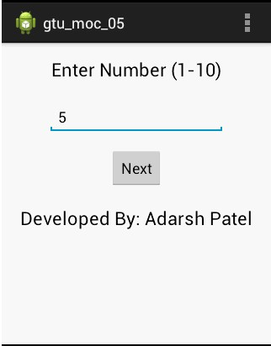 Output :

31
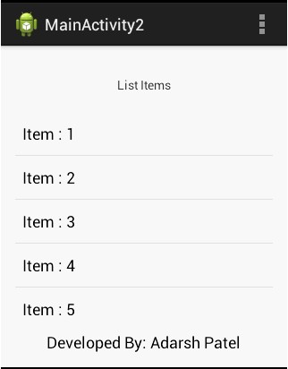CE373 D17CE137

Create spinner with strings taken from resource folder(res >> value folder). On changing spinner value, change image.
Activity_main.xml :
<RelativeLayout xmlns:android="http://schemas.android.com/apk/res/android" xmlns:tools="http://schemas.android.com/tools" android:layout_width="match_parent" android:layout_height="match_parent"
tools:context=".MainActivity" >

<Spinner android:id="@+id/spinner1" android:layout_width="wrap_content" android:layout_height="wrap_content" android:layout_alignParentTop="true" android:layout_centerHorizontal="true" android:entries="@array/S"
/>
<ImageView

32
CE373 D17CE137

android:id="@+id/imageView1" android:layout_width="fill_parent" android:layout_height="fill_parent" android:layout_alignTop="@+id/imageView1" android:layout_marginTop="32dp" android:layout_toRightOf="@+id/imageView1" />
</RelativeLayout>

MainActivity.java : import android.os.Bundle; import android.app.Activity; import android.view.Menu; import android.view.View;
import android.widget.AdapterView;
import android.widget.AdapterView.OnItemSelectedListener;
import android.widget.ImageView; import android.widget.Spinner; import android.widget.Toast;

public class MainActivity extends Activity implements OnItemSelectedListener { Integer[] aIDS={
R.drawable.one, R.drawable.two, R.drawable.three, R.drawable.four};
@Override
protected void onCreate(Bundle savedInstanceState) { super.onCreate(savedInstanceState); setContentView(R.layout.activity_main);

Spinner sp = (Spinner) findViewById(R.id.spinner1);
sp.setOnItemSelectedListener(this);
}

@Override
public boolean onCreateOptionsMenu(Menu menu) { getMenuInflater().inflate(R.menu.activity_main, menu); return true;

33
CE373 D17CE137

}

@Override
public void onItemSelected(AdapterView<?> arg0, View arg1, int arg2,long arg3)
{
Toast.makeText(this,"SELECTED ITEM IS :
"+arg0.getSelectedItem().toString(),Toast.LENGTH_SHORT).show(); ImageView ie = (ImageView) findViewById(R.id.imageView1);
ie.setImageResource(aIDS[arg2]);
}
}

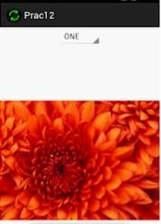 Output :

34
CE373 D17CE137

Create an application that will change color of the screen, based on selected options from the menu
Activity_main.xml :
<LinearLayout xmlns:android="http://schemas.android.com/apk/res/android" android:layout_width="fill_parent"
android:layout_height="fill_parent" android:orientation="vertical" android:id="@+id/mainactivity">

<TextView android:id="@+id/textView1" android:layout_width="match_parent" android:layout_height="match_parent" android:text="Hit Menu Button" android:gravity="center_vertical|center_horizontal"
android:textAppearance="?android:attr/textAppearanceLarge" />

</LinearLayout>
MainActivity.java : import android.app.Activity; import android.graphics.Color; import android.os.Bundle; import android.view.Menu; import android.view.MenuItem; import android.view.View;
import android.widget.AdapterView;
import android.widget.Button; import android.widget.EditText; import android.widget.ImageView; import android.widget.Spinner;

public class MainActivity extends Activity { View view1;

@Override
protected void onCreate(Bundle savedInstanceState) { super.onCreate(savedInstanceState); setContentView(R.layout.activity_main);

view1 = (View) findViewById(R.id.mainactivity);

35
CE373 D17CE137

}

@Override
public boolean onCreateOptionsMenu(Menu menu) {
// Inflate the menu; this adds items to the action bar if it is present. getMenuInflater().inflate(R.menu.main, menu);
return true;
}

@Override
public boolean onOptionsItemSelected(MenuItem item) {
// Handle action bar item clicks here. The action bar will
// automatically handle clicks on the Home/Up button, so long
// as you specify a parent activity in AndroidManifest.xml. if(item.getTitle().equals("Red"))
{
view1.setBackgroundColor(Color.RED);
}
else if(item.getTitle().equals("Green"))
{
view1.setBackgroundColor(Color.GREEN);
}
else if(item.getTitle().equals("Blue"))
{
view1.setBackgroundColor(Color.BLUE);
}

return super.onOptionsItemSelected(item);
}
}

36
CE373 D17CE137

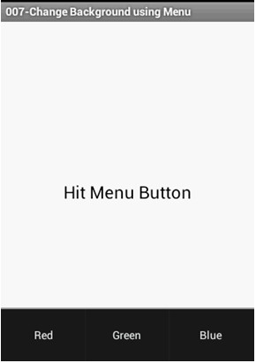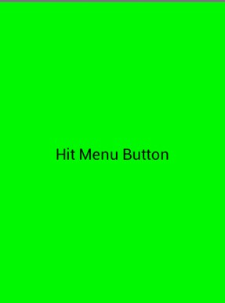 Output :

37

